

**Citizenship, Economics and Society**

**(Secondary 1-3)**

**Support Resources**

**Secondary 2**

**Module 2.4**

**Economic Performance and Human Resources of Hong Kong**

**Part 3:**

**Youth Employment in Hong Kong**

Personal, Social and Humanities Education Section

Curriculum Development Institute

Education Bureau

**Introduction**

* The “Citizenship, Economics and Society (Secondary1-3) Support Resources” covers the essential learning contents of Strands 1, 5 and 6 in the Personal, Social and Humanities Education Key Learning Area. It is designed to support the implementation of the Citizenship, Economics and Society curriculum.
* The support resources provide diversified learning activities to help

students acquire knowledge and understand concepts, develop skills

and nurture positive values and attitudes. In addition, they offer

teaching guidelines and suggestions on learning and teaching activities for teachers’ reference. Further, they provide reading materials to enhance students’ interest in reading.

* “Module 2.4 Economic Performance and Human Resources of Hong Kong Part 3: Youth Employment in Hong Kong” for Secondary 2 was developed by the Personal, Social and Humanities Education Section, Curriculum Development Institute of the Education Bureau. Part of the contents are based on the learning and teaching materials developed by the Business School of the Chinese University of Hong Kong and Hong Kong Effective Teaching Association, commissioned by our section in 2019 and 2014 respectively.

**Module 2.4 Economic Performance and**

**Human Resources of Hong Kong**

**Part 3: Youth Employment in Hong Kong**

**Contents**

|  |  |
| --- | --- |
|  | **Page** |
| **Introduction to the Resource** | 4 |
|  |  |
| **Teaching Design** |  |
| Lesson 1 to Lesson 4: Youth employment in Hong Kong | 5 |
|  |  |
| **Learning and Teaching Activities** |  |
| Lead-in Activity: Job Survey of Family Members | 9 |
| Prior Knowledge Worksheet: Relationship between economic development and labour demand of Hong Kong | 11 |
| Worksheet 1: Youth Unemployment Rate | 15 |
| Worksheet 2: Opportunities and Challenges for Youth Employment | 19 |
| Extended Learning Worksheet: Worldwide New Employment Trend: Gig Economy | 24 |
| Case Study: Opportunities and Challenges for Young People to Start a Business and Work in the Greater Bay Area (GBA) | 30 |
|  |  |
| **Reference** | 34 |

**Introduction to the Resource:**

This resource aims at introducing the employment opportunities and challenges for youth brought by the ups and downs of the economy and industrial development, for example, the emergence of new industries and changes in the mode of employment worldwide, and the availability of entrepreneurial and employment opportunities in the Guangdong-Hong Kong-Macao Greater Bay Area. Students will also learn the statistics of the labour market in Hong Kong, as well as changes in the number of employed persons in different industries, which serves as basic information for discussing related topics. The above learning contents help cultivate students’ entrepreneurial spirit[1], and encourage them to equip themselves early, be diligent and contribute to society, our country and the world.

**Prior Knowledge**

At the primary level, students have acquired a basic understanding of the major characteristics and development of the Hong Kong economy. Relevant learning contents in General Studies include “different occupations in the local community”, “major economic activities in Hong Kong”, “factors affecting the economic development in Hong Kong”, “major and emerging industries in Hong Kong”, as well as trade between Hong Kong, the Mainland and other parts of the world. Regarding mathematical skills, students have learned to collect and process data, and known how to use appropriate graphs to show the data and extract information from graphs

**Teaching Objectives:**

* To understand the knowledge related to the labour market
* To develop and cultivate relevant generic skills, values and attitudes

**Learning Points:**

* recognise the opportunities and challenges for youth employment brought by ups and downs in the economy, recent changes and future trends of industrial development;
* make informed analysis and judgement on topics and policies related to employment; and
* develop an entrepreneurial spirit and the virtue of diligence, broaden their global perspective, and contribute to society, our country and the world.

**Suggested Number of Lessons:**

* 4 lessons (40 minutes each)

**Teaching Design**

|  |  |  |
| --- | --- | --- |
| **Topic:** | Youth employment in Hong Kong | |
| **Duration:** | 4 lessons | |
| **Learning Objectives:** | * recognise the opportunities and challenges for youth employment brought by ups and downs in the economy, recent changes and future trends of industrial development; * make informed analysis and judgement on topics and policies related to employment; and * develop an entrepreneurial spirit and the virtue of diligence, broaden their global perspective, and contribute to society, our country and the world. | |
| **Lessons 1 and 2** | | |
| **Pre-lesson prepration:** | Students shall finish the following before class:   * Read “Lead-in Activity: Job survey of Family Members”, “Prior Knowledge Worksheet: Relationship between economic development and labour demand of Hong Kong” and “Prior Knowledge Enrichment Corner: Relationship between the economic development and labour demand of Hong Kong” and complete the activities. | |
|  |  | **Suggested lesson time** |
| **Enquiry Process:** | 1. **Set:**  * The teacher briefly introduces the contents of the four lessons and invites students to share their answers in the “Lead-in Activity: Job survey of Family Members” and “Prior Knowledge Worksheet: Relationship between economic development and labour demand of Hong Kong” with the class. The teacher then summarises the major industries in Hong Kong for different periods and the changes in academic and skills requirements in the labour market. * The teacher asks questions and invites students to share their views on future changes in the labour market. The teacher then guides them to reflect on how they can equip themselves to meet the future needs. | 15 minutes |
| 1. **Interactive teaching:**  * The teacher revises the concept and the calculation of unemployment rate with students by asking them questions. Students guess which age group has a relatively high unemployment rate. * The teacher uses “Worksheet 1: Youth unemployment rate” and asks students to form groups of two to finish Questions 1 to 3. Then the teacher invites students to share their answers and revisits the changes in unemployment of Hong Kong for the past two decades and its relationship with the economic performance. * The teacher asks students to form groups of two to finish Questions 4 to 6 and students share their answers and explanations. | 30 minutes |
| 1. **Interactive teaching:**  * The teacher asks students to read Sources 1 and 2 of “Worksheet 2: Opportunities and challenges for youth employment” and finish Questions 1 and 2. Students then share their answers and explanations. * Students then read Source 3 and form groups of two to discuss and finish Question 3. The teacher then invites a few groups to share their answers and bring out the message that as long as they work hard, there are still many opportunities in order to promote positive values. * The teacher revises the key learning points with the students by using “Knowledge Content: Opportunities and challenges for youth employment” and summarises the factors affecting youth employment and the opportunities and challenges for youth brought about by these factors.   **Extended learning activity (optional depending on the lesson time and students’ ability level):**   * The teacher distributes “Extended Learning Worksheet: Worldwide new employment trend: Gig economy” and asks the students to read the Sources. Then students form groups of two for discussion and finish the questions. After that, the teacher invites a few groups to share their answers and offers feedback on their answers. | 30 minutes |
| 1. **Conclusion:**  * The teacher summarises the lesson and explains the requirements of the homework briefly. | 5 minutes |
| **Homework:** | * Students finish the online quizzes to understand more their interests and abilities, which will help them explore occupations that would be suitable for them: <https://www.talent.gov.hk/selfAssessment?lang=en_US> * Students read “Know More: Manpower Projection to 2027” to understand the changes in the manpower requirements in 2017 and 2027 and share on which industries that they would like to work in when they grow up. | |
| **Learning and Teaching Resources:** | Lead-in Activity; Prior Knowledge Worksheet; Worksheets 1-2; Extended Learning Worksheet | |

|  |  |  |
| --- | --- | --- |
| **Lessons 3 and 4** | | |
|  |  | **Suggested Lesson Time** |
| **Enquiry Process:** | 1. **Set:**  * The teacher plays the video “Understanding the GBA” (Chinese only) and uses the ”Case Study: Opportunities and challenges for young people to start a business and work in the Greater Bay Area (GBA)” to help students have a basic understanding of the GBA. | 15 minutes |
| 1. **Interactive teaching:**  * The teacher asks students to form groups of two to read the Sources and finish Questions 1 to 2. After discussion, the teacher invites students to share their answers and offers feedback on students’ work. This part stimulates students to think about the pull factors which attract young people to work in cities of GBA and the opportunities brought about by GBA. * The teacher asks students to form groups of two to finish Question 3. After discussion, the teacher invites students to share on the challenges that young people from Hong Kong may face when they work in the GBA. | 50 minutes |
| 1. **Conclusion and students’ reflection:**  * The teacher asks students, “Young people face many opportunities and at the same time, the competition is also great. What do you think about your competitiveness in the labour market?”. “As you are studying now, is there any way for you to increase your competitiveness in the future labour market?” Students reflect on the above questions at home. * The teacher summarises the lesson. | 15 minutes |
| **Learning and Teaching Resources:** | Case Study; Video | |

**Module 2.4 Economic Performance and Human Resources of Hong Kong**

**Part 3: Youth Employment in Hong Kong**

**(Lesson 1 to Lesson 4)**

**Learning and Teaching Materials**

**Lead-in Activity: Job Survey of Family Members**

Conduct interviews with two elders in your family (e.g. parents, grandparents or other relatives) and one employed sibling (if any) to learn about their working experience and fill in the table below.

Example: Relationship with the interviewee: **Grandmother**

|  |  |  |  |
| --- | --- | --- | --- |
| **Year** | **Job of the interviewee** | | |
| **Company Name** | **Post** | **Industry** |
| 1971-1980 | May May Garment Factory | Garment worker | Clothing Industry |
| 1981-2000 | ABC Fast Food | Cleaning worker | Catering Industry |
| 2001-2010 | ABC Fast Food /  Copper Lion Building | Cleaning worker /  Security guard | Catering Industry /  Property management |
| 2011- present | Copper Lion Building | Security guard | Property management |

Relationship with the interviewee: **____________________**

|  |  |  |  |
| --- | --- | --- | --- |
| **Year** | **Job of the interviewee** | | |
| **Company Name** | **Post** | **Industry** |
| 1971-1980 |  |  |  |
| 1981-2000 |  |  |  |
| 2001-2010 |  |  |  |
| 2011- present |  |  |  |

Relationship with the interviewee: **____________________**

|  |  |  |  |
| --- | --- | --- | --- |
| **Year** | **Job of the interviewee** | | |
| **Company Name** | **Post** | **Industry** |
| 1971-1980 |  |  |  |
| 1981-2000 |  |  |  |
| 2001-2010 |  |  |  |
| 2011- present |  |  |  |

Relationship with the interviewee: **____________________**

|  |  |  |  |
| --- | --- | --- | --- |
| **Year** | **Job of the interviewee** | | |
| **Company Name** | **Post** | **Industry** |
| 1971-1980 |  |  |  |
| 1981-2000 |  |  |  |
| 2001-2010 |  |  |  |
| 2011- present |  |  |  |

Extended discussion:

1. Collect the survey results of your classmates, and summarise the jobs and positions the interviewees held during different periods of time.
2. How did the employment of the interviewees relate to the economic development of Hong Kong?

**Prior Knowledge Worksheet: Relationship between economic development and labour demand of Hong Kong**

With the change of economic environment, Hong Kong has undergone changes in economic development for several times in the past decades. Do you know what industries were dominant in Hong Kong during different periods of time? How has labour demand changed with time?

 Students can learn the change in labour demand during different periods of time in Hong Kong based on the information below.

**Source 1**

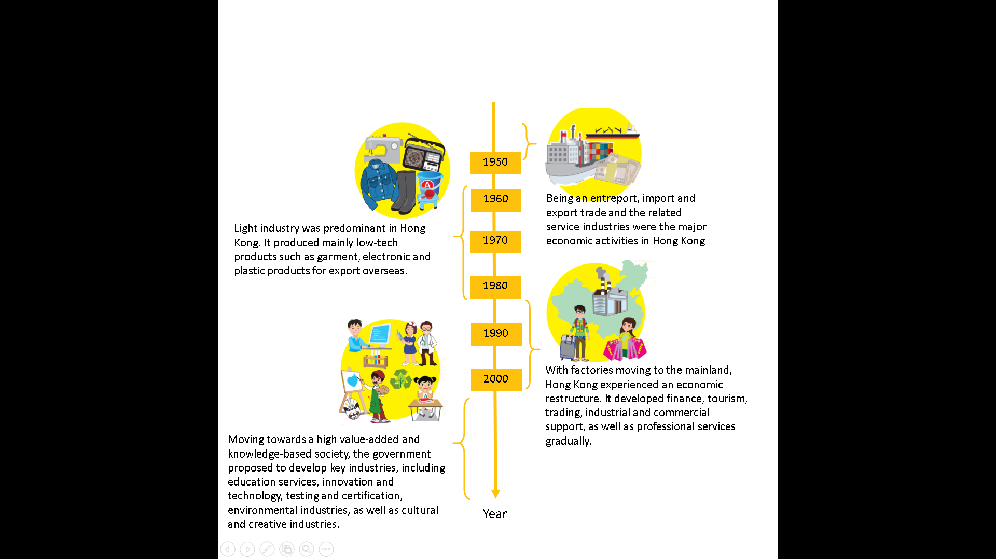

**Think about it:**

**Can you give some examples of industries that the government has actively promoted in recent years?**

**Source 2**

Labour demand varies with the economic environment. Below are the stories of six people. Try to analyse and learn about the labour characteristics of Hong Kong in different periods of time.

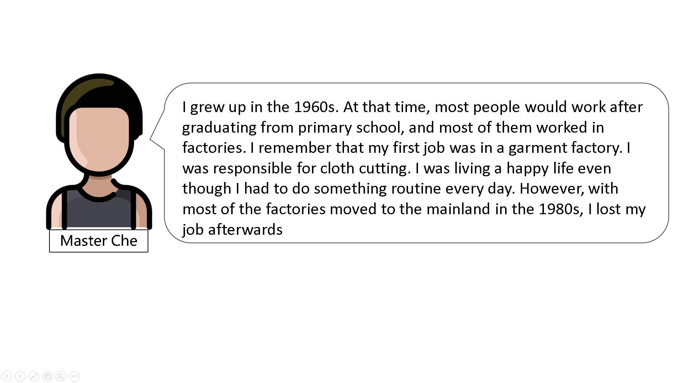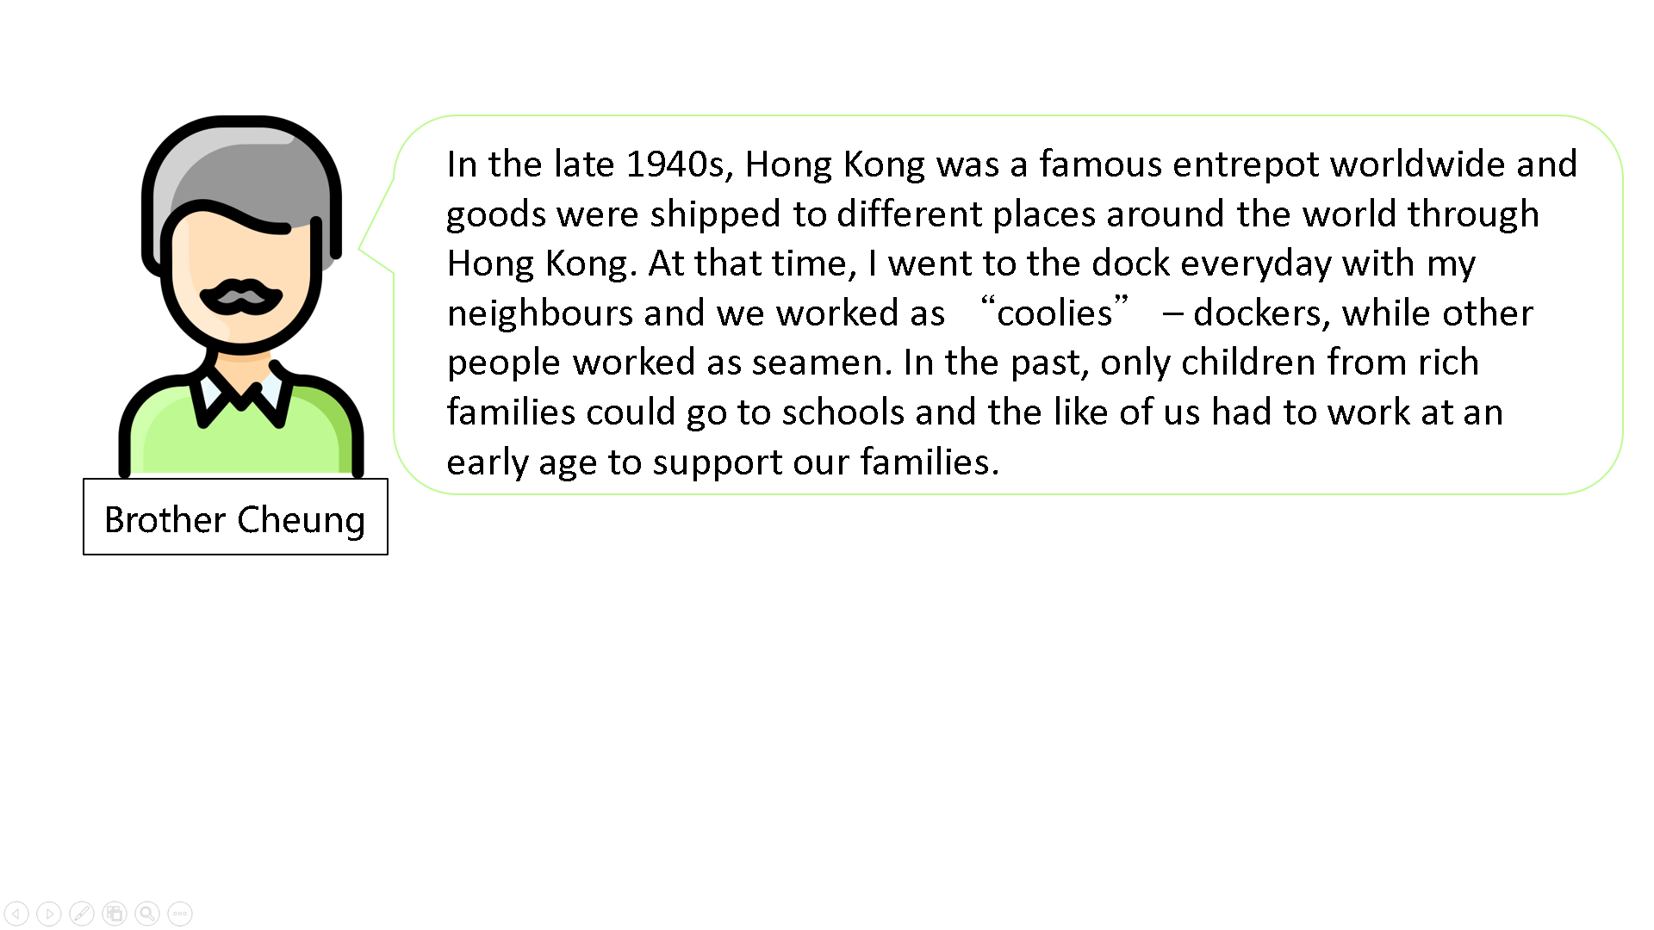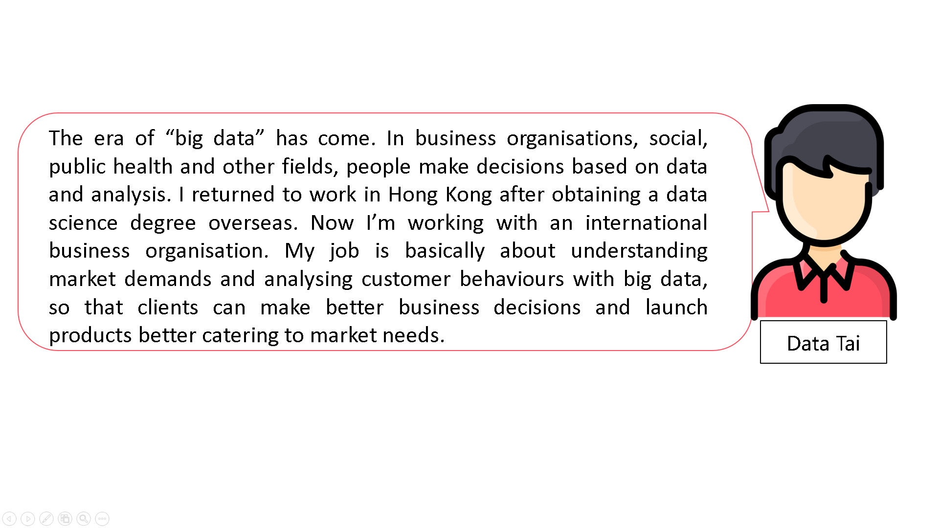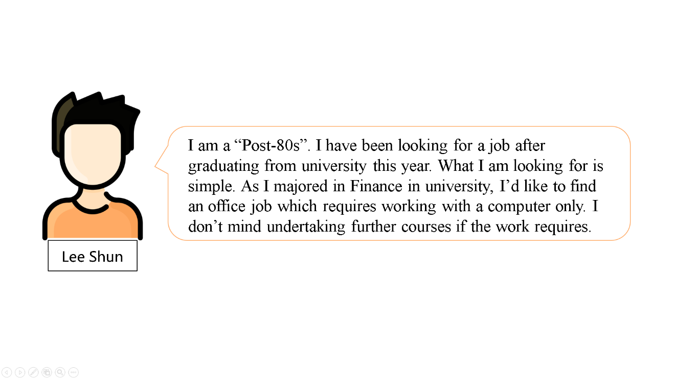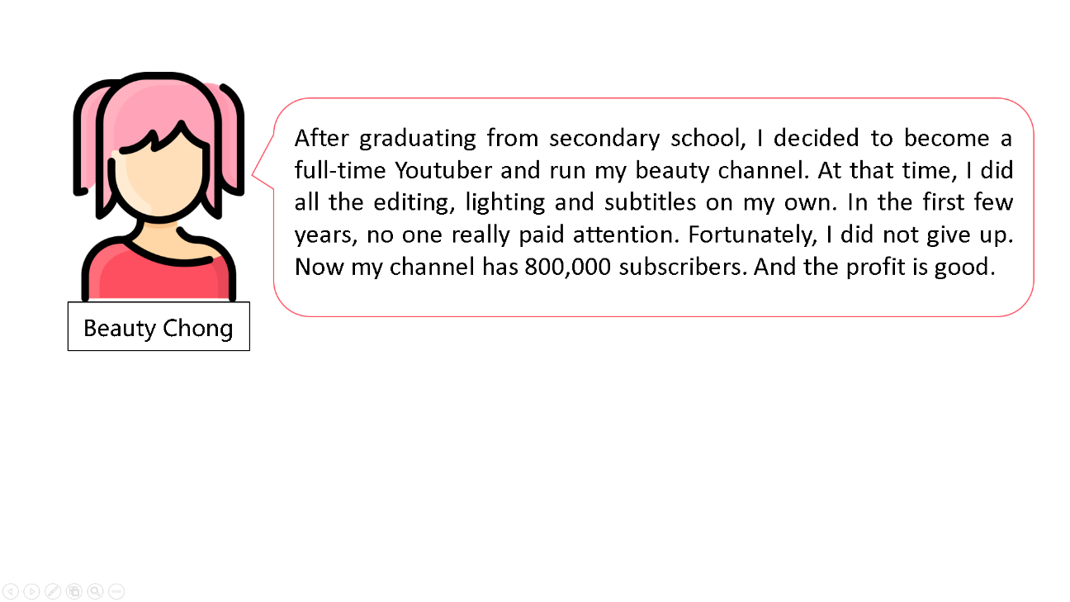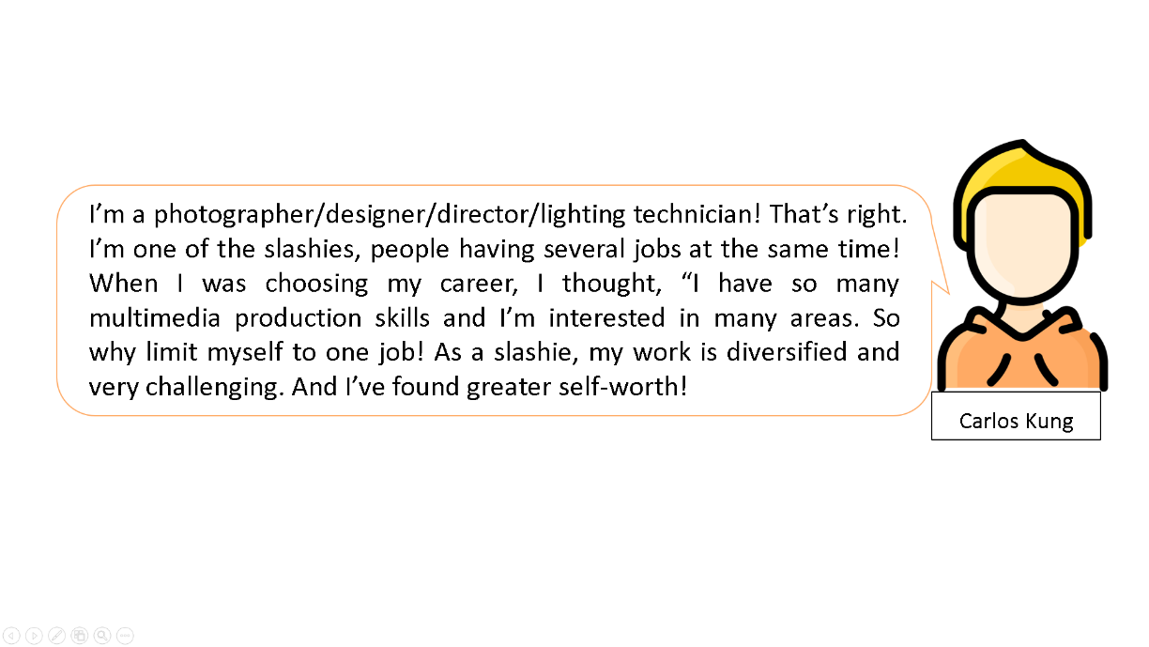

Based on Sources 1 and 2 above, analyse the main industries, as well as the academic qualifications and skills required of the labour force in different periods.

|  |  |  |  |
| --- | --- | --- | --- |
| **Period** | **Person in Source 2** | **Major industries** | **Characteristics of labour in the industry**  **(E.g., academic qualifications, skills)** |
| 1940-1950 | *Brother Cheung* | *Import and export trade, handling goods at the dock* | *No academic qualifications or skills are required* |
| 1950-1970 | *Master Che* | *Manufacturing* | *Low academic qualifications, low skills* |
| 2000 | *Lee Shun* | *Service sector* | *High academic qualifications and professional skills* |
| Post-2010 | *Data Tai* | *Information and communications technology* | *High academic qualifications and professional skills* |
| Post-2010 | *Beauty Chong* | *Cultural and creative industries* | *No specific academic requirements; relevant skills required (e.g., video editing skill)* |
| Post-2010 | *Carlos Kung* | *Cultural and creative industries* | *No specific academic requirements; multiple skills required* |

**Prior Knowledge Enrichment Corner**

|  |
| --- |
| **Relationship between the economic development and labour demand of Hong Kong**  Labour demand of Hong Kong has undergone great changes in the past few decades. During the 1970s and 1980s, light industries were predominant in Hong Kong with manufacturing industries as the backbone of the economy. Labour-intensive industries, such as garment, toys and textile had a huge demand for low-skilled and less-educated labour force. However, with most of the factories moving to the Mainland since the 1980s for a lower production cost, manufacturing industries declined gradually in Hong Kong. With the booming of service industries such as finance and trading, Hong Kong economy became more dependent on service industries.  Nowadays, Hong Kong is a service-oriented economy. The government encourages the development of a knowledge-based economy, focusing on high value-added services, such as finance, trading and logistics, tourism, industry and commerce support and professional services (four pillar industries). Moreover, it also promotes the development of information technology and information services industries, innovation and technology industries, and cultural and creative industries. It reveals a change of demand on the labour force. Professional, educated and skilled labour is preferable for its economic development. |

**Think About It**

What is the direction for the future development of Hong Kong? What will be the demand for labour after I graduate ? And how can I prepare for it?

|  |
| --- |
| *Hong Kong will develop into a knowledge-based economy, focusing on high-value* |
| *added services. The labour market will need workers with high* |
| *qualifications, professional knowledge and high-tech skills. Different innovation,* |
| *cultural and creative industries and even some industries that we have never* |
| *thought of emerge. As a student, I should pay attention to the changes of the labour* |
| *market and work hard to acquire knowledge and skills, in particular generic skills* |
| *(such as communication skills, problem solving skills and creative thinking) so as* |
| *to meet the needs of a knowledge-based economy.* |

**Online Learning:**

Browse the website of the Census and Statistics Department to understand the employment situation in Hong Kong in recent years.

https://www.censtatd.gov.hk/en/scode200.html

**Worksheet 1: Youth Unemployment Rate**

**Concept recap:**

**Unemployment Rate**

The unemployment rate refers to the proportion of unemployed population in the labour force

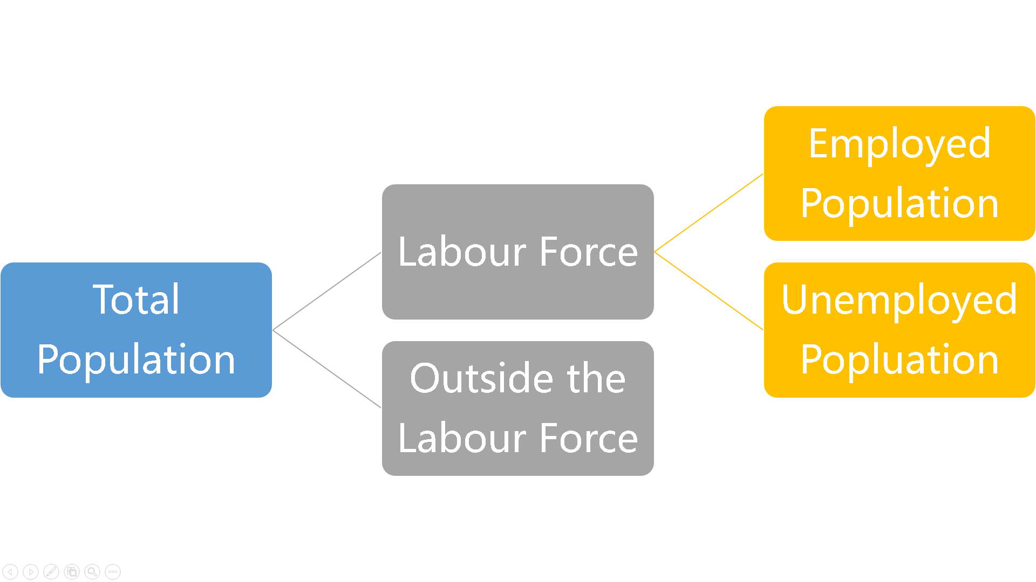

**Source 1: Unemployment rate of Hong Kong 2000-2020**

Source: Census and Statistics Department

<https://www.censtatd.gov.hk/en/web_table.html?id=6>

1. According to Source 1, what were the highest and lowest unemployment rates in Hong Kong during the past 20 years? In which year did they appear?

|  |
| --- |
| *In the past two decades, Hong Kong’s unemployment rate was the highest in* |
| *2003, about 8%. Since then, the unemployment rate has generally fallen from* |
| *a high level and changed with economic fluctuations during the period.* |
| *According to the above chart, the unemployment rate in 2018 was the lowest,* |
| *only about 3%. However, Hong Kong’s unemployment rate was about 6% in* |
| *2020 when there was an outbreak of the Covid-19 epidemic.* |
|  |
|  |

1. Refer to the Internet and books, try to point out the important events that have affected Hong Kong’s unemployment rate in 2003, 2009 and 2020.

|  |
| --- |
| *2003：the SARS epidemic* |
| *2009：2008 Global Financial Crisis* |
| *2020: the outbreak of the Covid-19 epidemic* |
|  |

1. How is the unemployment rate related to the economic condition? Why?

|  |
| --- |
| *When the economic situation is bad, the purchasing power of people will be* |
| *weak. It will hit the retails and catering industries. As a result, the demand for* |
| *labour will be lower and unemployment rate increases.* |
|  |
|  |
|  |

**Source 2: ︰Unemployment rate of particular age groups in Hong Kong 2000-2019**

Source: Census and Statistics Department (2020) (Table E021 : Unemployed persons by age and sex (Table 2.1 in Quarterly Report on General Household Survey)

<https://www.censtatd.gov.hk/en/EIndexbySubject.html?pcode=D5250025&scode=200>

1. Compare the data of unemployment rate of Hong Kong as a whole in Source 1 and the data of unemployment rate of particular age groups in Source 2. Generally speaking, what is the difference between the two?

|  |
| --- |
| *The unemployment rate of teenagers in the 15-19 and 20-29 age groups is higher* |
| *than the overall unemployment rate. The unemployment of the 15-19 age group* |
| *is particularly serious, being at least doubled that of the overall unemployment rate.* |
| *(Note: It should be noted that many in the 15-19-year-old population are* |
| *students, and hence the working population in this age group is smaller.* |
| *However, the unemployment rate is calculated as the ratio of the* |
| *unemployed to the working population. Therefore, it is possible that the* |
| *unemployment rate of this age group is higher than the overall unemployment* |
| *rate.)* |
|  |
|  |

1. Why do people in the 15-19 age group face greater employment difficulties?

|  |
| --- |
| *People in this age group are mostly less educated and have little work* |
| *experience. They lack competitiveness and tend to have difficulties in finding a* |
| *job. Therefore, the unemployment rate of this age group is higher than those of* |
| *other age groups.* |
|  |
|  |

1. Compare the unemployment rate of Hong Kong as a whole in Source 1 and those of the age groups in Source 2. What is the impact of an economic downturn on the employment of young people? (Hint: What factors will affect the employment of young people?)

|  |
| --- |
| *According to Sources 1 and 2, the unemployment rate of young people,* |
| *especially that of the 15-19 age group, is obviously higher than the territory-wide* |
| *figure. Taking the two unemployment peaks in 2003 and 2009 as examples, in* |
| *2003, the unemployment rate of the 15-19 age group was around 30%, being at* |
| *least triple the territory-wide figure which was around 8%. In 2009, there was a* |
| *significant gap between the unemployment rate of the 15-19 age group which* |
| *was over 20% and the territory-wide figure which was over 5-6%.* |
| *In an economic downturn, many companies have to lay off people, making it even* |
| *more difficult for inexperienced young people to find suitable jobs. As a result,* |
| *the youth unemployment rate rises.* |
|  |
|  |
|  |

**Think about this:**

**The economic downturn and job shortfall make it more difficult for young people to secure employment. However, opportunities exist even in adverse situations. For example, during the outbreak of the COVID-19 epidemic, some companies found business opportunities by exploring and strengthening online sales channels. Can you think of other examples of resilience against adversities?**

**Worksheet 2: Opportunities and Challenges for Youth Employment**

**Source 1: Nancy’s story**

|  |
| --- |
| Nancy completed Secondary 6 this year. This is her story during the COVID-19 epidemic:  “The economic conditions of my family are not good. And my academic performance is not satisfactory. So I want to start working as soon as possible to get practical working experience. And on the other hand, I can earn money and lessen the financial burden of my family. I would like to work in the tourism or the retail industry. Unfortunately, I still can’t find a job after graduation for more than six months. I’ve attended many interviews, but all in vain....” |

**Source 2: A report about Stark Chan Yik-hei, “Son of the Star”**

|  |
| --- |
| “Stark came from a grassroots family. With his curiosity and self-motivation, he excelled in a scientific competition. And Massachusetts Institute of Technology (MIT) named an asteroid after him when he was only 14.  After completing Secondary 5, Stark was granted special admission into the Hong Kong University of Science and Technology for the Bachelor Programme of Electronic and Computer Engineering. The world is paying more and more attention to innovation and technology development. So after graduation, Stark founded an IT start-up for programming and participated in the government-sponsored Cyberport Incubation Programme. He received more than 300,000 Hong Kong dollars in subsidies and a rent-free office for two years.” |

References:

Global Views Monthly (2016). *Hong Kong’s Innovative and Tech-wise Youths* (玩創新 解碼香港年輕創科新力量).

Chan Ka-wai (12 November 2019). *From Son of the Star to Entrepreneur* (從星之子到創業者). Master Insight.

Jumpstart Publishers (2016). *My Dream - Stark Chan, “Son of the Star”* (《我的夢想——「星之子」陳易希》)

**Source 3: An online article about AI**

|  |
| --- |
| The development of robots and Artificial Intelligence (AI) has entered its golden era in recent years. Robots replacing humans in workplaces is no longer just a plot in science fiction movies, it happens in real life. According to a report published by the McKinsey Global Institute in 2017, repetitive tasks generally have higher automation potential. It was estimated that half of the current tasks in the global economy would be automated by around 2055. Meanwhile, some of the higher-skilled occupations, such as lawyers and accountants, are also affected by automation. Are robots and AIs our friends or foes? Will they replace humans? |

Source: Web page of HKSAR Government Human Resources Planning Commission, [https://www.talent.gov.hk/onlineMagazineDetail/65?lang=en_US&name=AI%E6%AE%BA%E5%88%B0%E5%9A%9F-%E4%BA%BA%E9%A1%9E%E5%86%87%E5%9F%9E%E4%BC%81](https://www.talent.gov.hk/onlineMagazineDetail/65?lang=en_US&name=AI殺到嚟-人類冇埞企)

1. Based on Source 1, analyse the employment challenges faced by Nancy.

|  |
| --- |
| *Factors include the economic downturn, the decline in demand for labour, and* |
| *the reduction of jobs. In addition, Nancy is a fresh graduate. She does not* |
| *have relevant experience in the industry, which makes it more difficult for her* |
| *to find a job in her desired sector (tourism or retail industry).* |
|  |
|  |

1. Based on Source 2, analyse the factors contributing to Stark Chan’s success.

|  |
| --- |
| *While Stark Chan’s family background and academic performance were not* |
| *very good, he managed to find his own interest and develop his unique skills.* |
| *He achieved impressive achievement with perseverance and persistence.* |
| *Besides, in the time of economic transformation, the world is paying more and* |
| *more attention to innovation and technology development. And the demand for* |
| *related skills increases in society. Stark Chan seized the opportunity and* |
| *benefited from the Government’s support programme for entrepreneurship.* |
| *So he succeeded.* |
|  |

1. Based on Source 3, discuss with your classmates the changes that the AI development will bring to the job market.

|  |
| --- |
| *With the advancement in AI technology, many jobs may be replaced by AI. Both* |
| *low-tech positions and professional ones will be affected. But on the other hand,* |
| *AI development and applications will create new products and services and* |
| *create new demands and opportunities. It will also generate new jobs, businesses* |
| *and economic incomes.* |
|  |



**Opportunities and Challenges for Youth Employment**

There are many factors that affect the employment of young people, such as their own personalities, academic qualifications, job-hunting goals. There are even uncontrollable factors, such as personal experiences and luck, which also affect their employment opportunities. Here we will focus on the opportunities and challenges brought about by ups and downs in the economy, industrial development and policy-related factors to youth employment.

1. **Ups and downs in the economy**

**Hong Kong as a small and open economy**

**Economic environment is one of the factors affecting employment.**  Since **Hong Kong’s main economic activities are closely connected with other regions in the world,** local economic development can be easily affected by **external factors. If the external economies turn bad,** such as the Asian Financial Crisis in 1997-98 and Global Financial Crisis in 2008, Hong Kong’s economic performance will be seriously affected. Additionally, some occasional incidents, such as the outbreak of the COVID-19 epidemic in 2019, resulted in global and local recession. Under such circumstances, corporations would cut down operational cost by reducing their employment of labour. Therefore, unemployment rate will rise in the years of economic recession. It is even a greater challenge for young people with less education and experience.

**Fierce competition in the labour market**

Due to the high labour cost in Hong Kong and competition brought by **globalisation, some service-related positions have been relocated to other places.** Besides, the number of local university graduates has increased rapidly. Therefore, competition in Hong Kong’s labour market has become increasingly fierce. Facing the rapidly changing labour market, young people need not only acquire more skills, but also cooperate and compete with people from different places.

1. **Industrial development**

**Changes in Industries**

Hong Kong has undergone many economic changes over the past decades. The local economy has gradually changed from industry-oriented into **service-oriented**. **With the development of innovative technologies,** especially the advancement of the AI technology, **many jobs may be replaced.** Both low-tech positions and professional ones will be affected. But on the other hand, AI development and applications **will create new products and services** and bring about new demands and opportunities. It will also generate new jobs, businesses and economic incomes.

1. **Policy support**

A lot of local young people aspire to start their own business. But they lack sufficient capital and experience. It is difficult for them to succeed without support. In view of the situation, **the Government has made concerted efforts with various sectors of the community to provide strong support for youth innovation and entrepreneurship** in recent years**.** Related initiatives include the “Youth Development Fund” and the “Space Sharing Scheme for Youth”. Besides, Hong Kong Science Park and Cyberport have rendered holistic support for start-ups.

References:

News.gov.hk. A blog article by Financial Secretary Paul Chan: *A bumpy road to recovery* (26 July 2020)

News.gov.hk. Video speech by Financial Secretary Paul Chan at the 70th Anniversary Conference of the Association of Chartered Certified Accountants (Hong Kong). *Grasp development opportunities through political and economic lenses* (認清政經格局 把握發展機遇). (18 September 2020)

The Chinese Manufacturers’ Association of Hong Kong. *Artificial Intelligence: A Technology Changing the World*.

Lee Shu Kam (2017). *Career Experiences of Youth in Hong Kong*.

News.gov.hk. A blog article by Chief Secretary for Administration: Innovation and start-ups drive youth mobility. (10 November 2019)

**Extended reference**

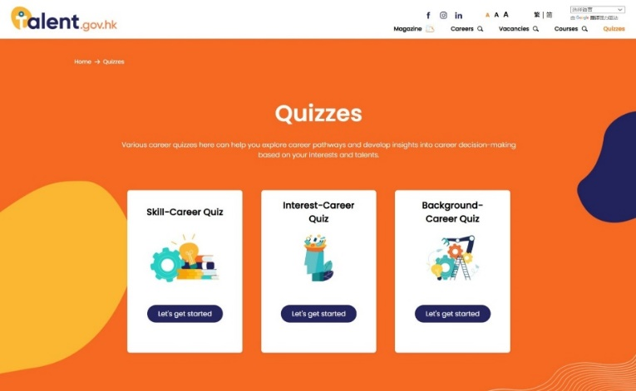

Website of HKSAR Government Human Resources Planning Commission:

Various career quizzes here can help you explore career pathways based on your interests and talents.

<https://www.talent.gov.hk/selfAssessment?lang=en_US>

**Extended Learning Worksheet**

“Gig economy” generally refers to the practice that people sign work contracts through Internet platforms, usually for short-term and temporary hires.

**Worldwide New Employment Trend: Gig Economy**

**Source 1: A brief introduction of Slashies**

|  |
| --- |
| With the advancement of the Internet and the rise of the gig economy, the slashie culture has become a popular work style among young people in recent years. Slashies, also known as slashers or multi-hyphenates, refer to young people who are no longer settled for a single job but instead choose a diverse life with multiple occupations and identities. They give up the conventional work pattern in society mostly because of their expertise or interest. Generally speaking, when asked about their occupations, slashies tend to place their jobs between slashes, such as doctor/dance teacher or photographer/cook. Why are there slashies? Some people explain that the new generation does not want to limit themselves to a single job. Others believe that the new generation has more choices and want to have them all. Some regard it as a phenomenon of globalisation. The new generation no longer needs a fixed office and has more flexibility and possibilities at work. It reflects the changes in social and economic patterns. The labour market is changing as well. |

Reference:

ET Net (4 May 2018). *Rise of the Planet of Slashies: Dreams/Money/Diverse Life* (【Slash世代】斜槓族全球冒起 圓夢／掘金／多元人生). Retrieved from

<http://www.etnet.com.hk/www/tc/news/topic_news_detail.php?category=special&newsid=8886>

The Academy of Chinese Studies (21 February 2020). *Slashies’ Experience of Multiple Lives* (斜槓族 體驗多重人生) LS Modern China. Retrieved from <https://ls.chiculture.org.hk/tc/hot-topics/449>

**Source 2: Views of stakeholders**

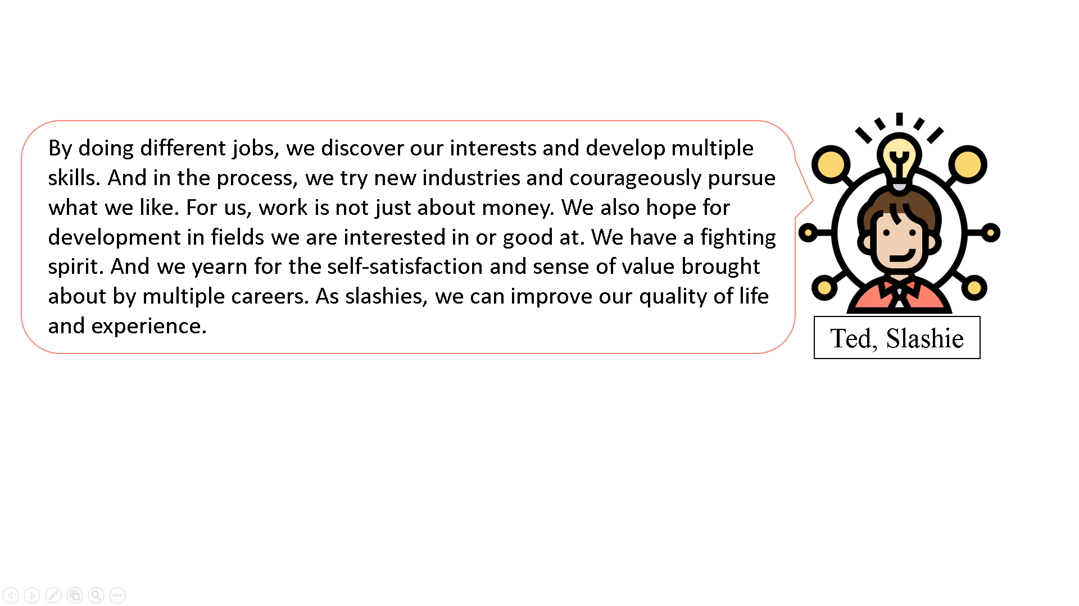



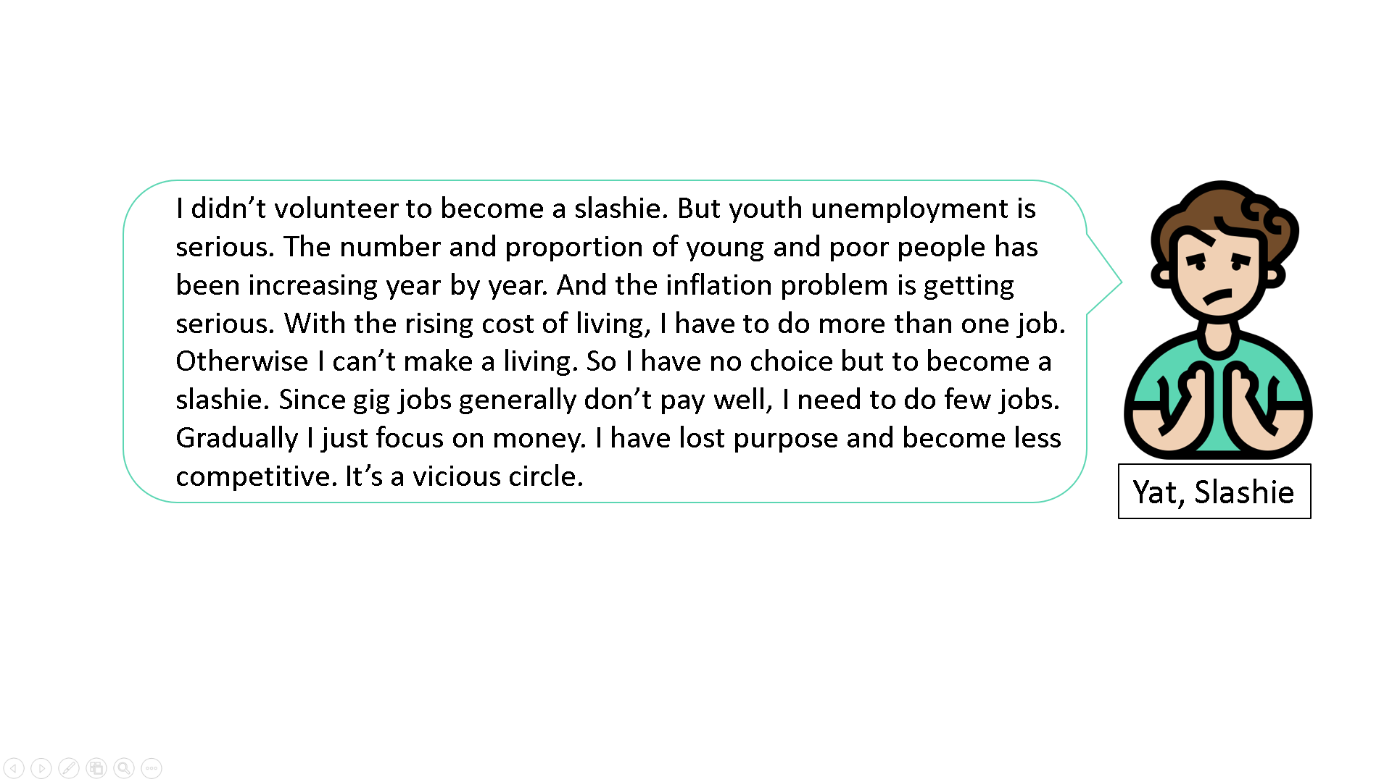

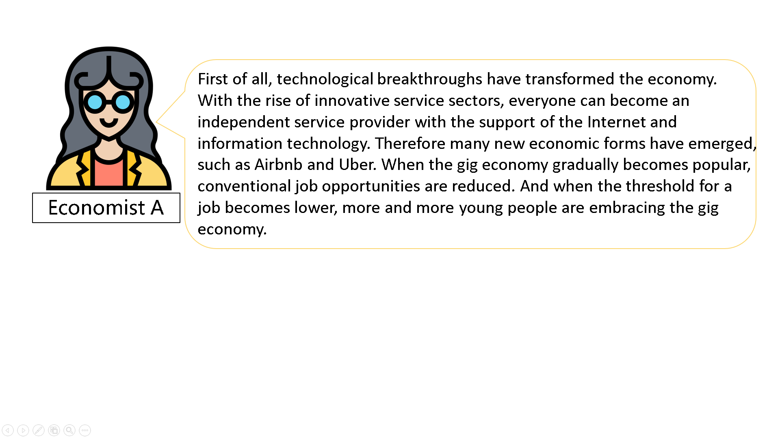

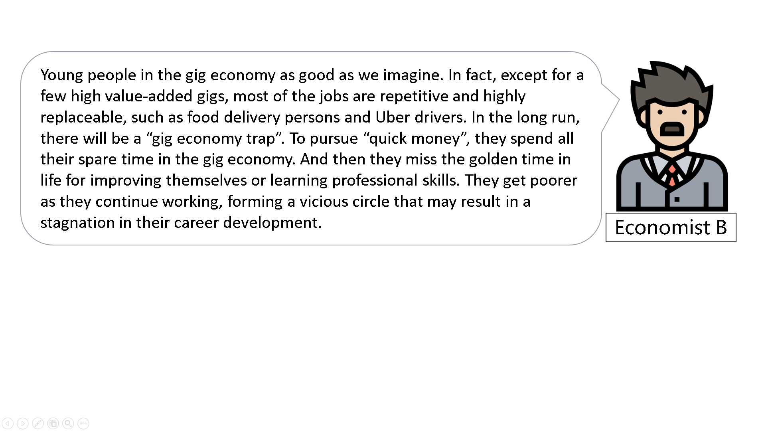

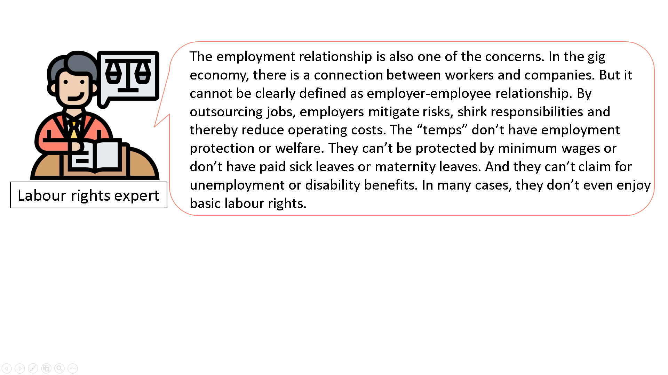

References:

Sze Man Man (3 January 2020). *Slashies and Gig Economy Become New Employment Trends as New Generation Rejects Singular Work Experience* (新世代不甘單一工作經驗　Slash族與零工經濟成職場新趨勢). Hong Kong Economic Times.

Leo Chu (9 January 2020). *Gig Economy: “Quick Money” or Greater Collective Poverty?* (零工經濟用「快錢」當誘因，可能造成更大的集體貧窮問題). The News Lens.

Ng Cheuk Fung (21 June 2020). *Unemployment Rate at 5.9%, Even Higher at 13.4% for the 20-24 Age Group, Matthew Cheung Says* (失業率5.9%　張建宗稱20至24歲青年失業率13.4%情況更嚴重). Hong Kong Economic Times.

Wang Ruo-jie (11 May 2016). *Gig Economy: New Value of Fragmented Time* (零工經濟： 零碎時間的新價值). eyeProphet.

Pofeldt, E. (2016, October 10). *McKinsey Study: Gig-Economy Workforce Is Bigger Than Official Data Shows in U.S., Europe*. Forbes.

Answer the following questions.

1. Determine whether the following statements about slashies are right or wrong.

|  |  |  |
| --- | --- | --- |
| 1. Slashies refer to young people with multiple occupations. | Right | Wrong |
| 1. Slashies work entirely based on their interests. | Right | Wrong |
| 1. The emergence of slashies shows that the economy of the society is changing, thereby changing the labour market. | Right | Wrong |
| 1. Economic transformation drives the emergence of slashies. | Right | Wrong |
| 1. Slashies can enjoy more freedom and flexibility at work. | Right | Wrong |
| 1. Slashies enjoy the same labour rights as conventional workers. | Right | Wrong |
| 1. Most slashies are doing highly repetitive and replaceable jobs. | Right | Wrong |

1. What opportunities does the gig economy model bring to young people?

|  |
| --- |
| *Young people improve their quality of life and experience by being slashies. Not* |
| *only can they develop their interest or expertise and earn more money, but* |
| *they can also explore diverse careers and get a sense of satisfaction. In addition,* |
| *the gig economy gives young people opportunities for self-enhancement. At* |
| *the same time they can enjoy much freedom and flexibility at work. It helps* |
| *accumulate different work experiences. And it inspires them and develops their* |
| *social network.* |
|  |
|  |

1. What challenges do young people face when they choose the gig economy model? Why do they still choose to be slashies?

|  |
| --- |
| *Many gig jobs are highly repetitive and replaceable. Young people engaged in* |
| *the gig economy do not keep learning and equip themselves with new skills, with the result they* |
| *may have stagnation in their career development. Besides, the employer-* |
| *employee relationship in the gig economy model cannot be clearly defined.* |
| *Therefore employers will not provide corporate protection or welfare. The* |
| *labour rights of slashies may not be well-protected.* |
| *Technological breakthroughs have transformed the economy. Conventional job* |
| *opportunities are reduced. The threshold for a job becomes lower in the gig* |
| *economy. As a result, young people who cannot find a full-time job in* |
| *conventional sectors have no choice but to become slashies. On the other hand,* |
| *some young people want to pursue their career in the fields of their interest or* |
| *expertise. Or they want freedom at work. So they choose the gig economy model.* |
|  |
|  |
|  |
|  |



Appendix 1

**To Know More: Manpower Projection to 2027**

Make reference to the following information and understand the demand for labour of different industries in 2017 and 2027.

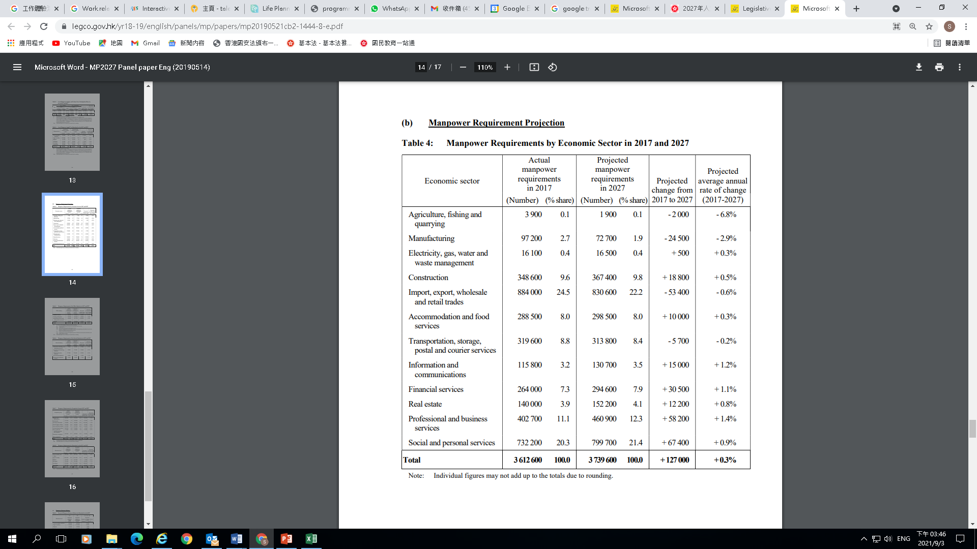





Source: Key Findings of Manpower Projection to 2027 (Dec 2019)

<https://www.legco.gov.hk/yr18-19/english/panels/mp/papers/mp20190521cb2-1444-8-e.pdf>

**Reflection**

In what industry do you want to work when you grow up? What do you expect about the prospect of that industry when you graduate from school?

**Case Study: Opportunities and challenges for young people to start a business and work in the Greater Bay Area (GBA)**

Watch the video clip to get a preliminary understanding the Guangdong-Hong Kong-Macao Greater Bay Area

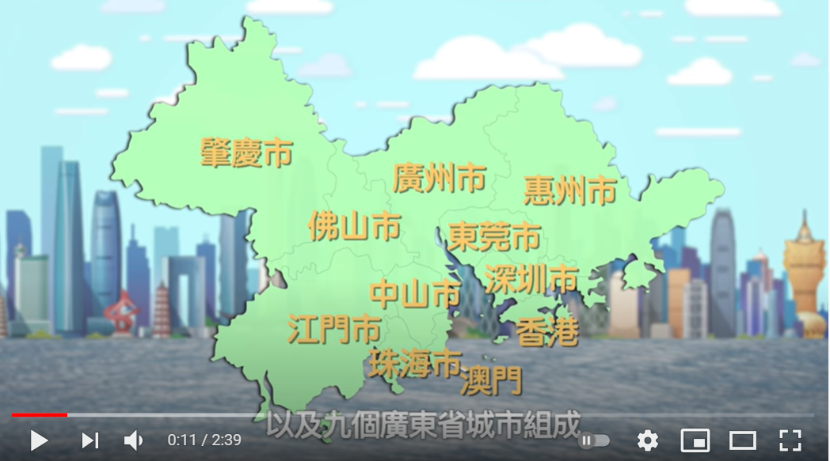

 The Academy of Chinese Studies, Understanding the GBA

https://youtu.be/UlyivWYH7NY

**Source 1: Views of stakeholders**

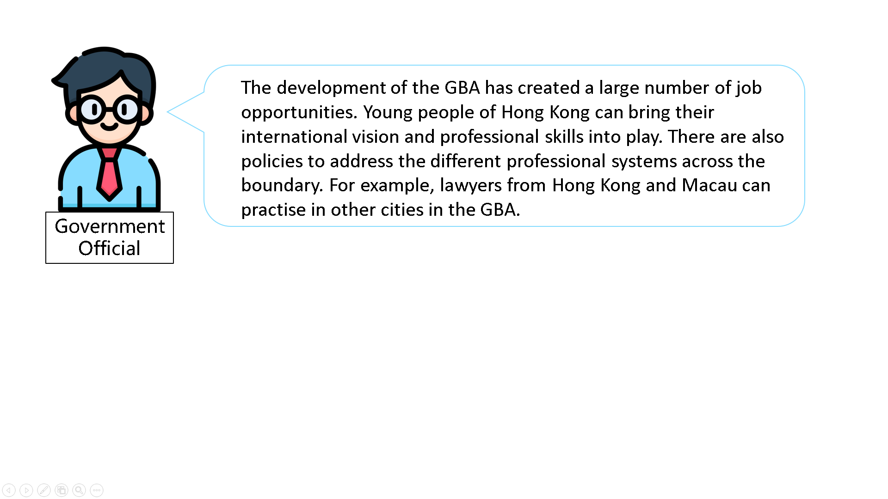

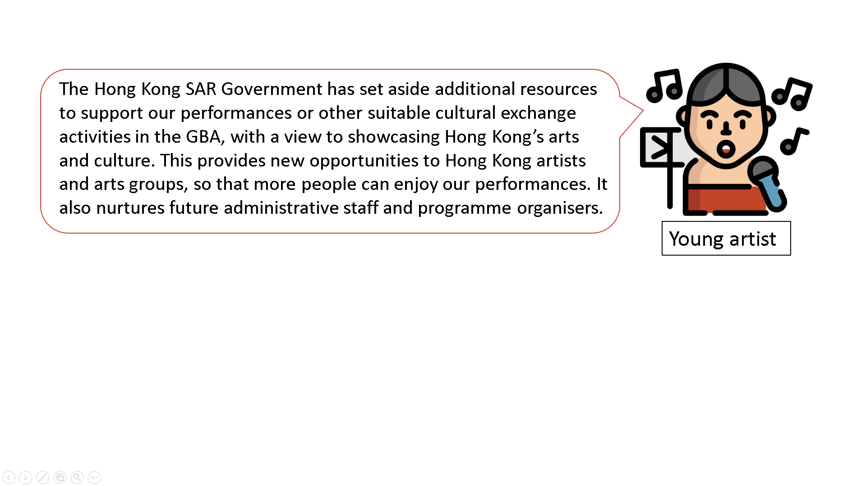

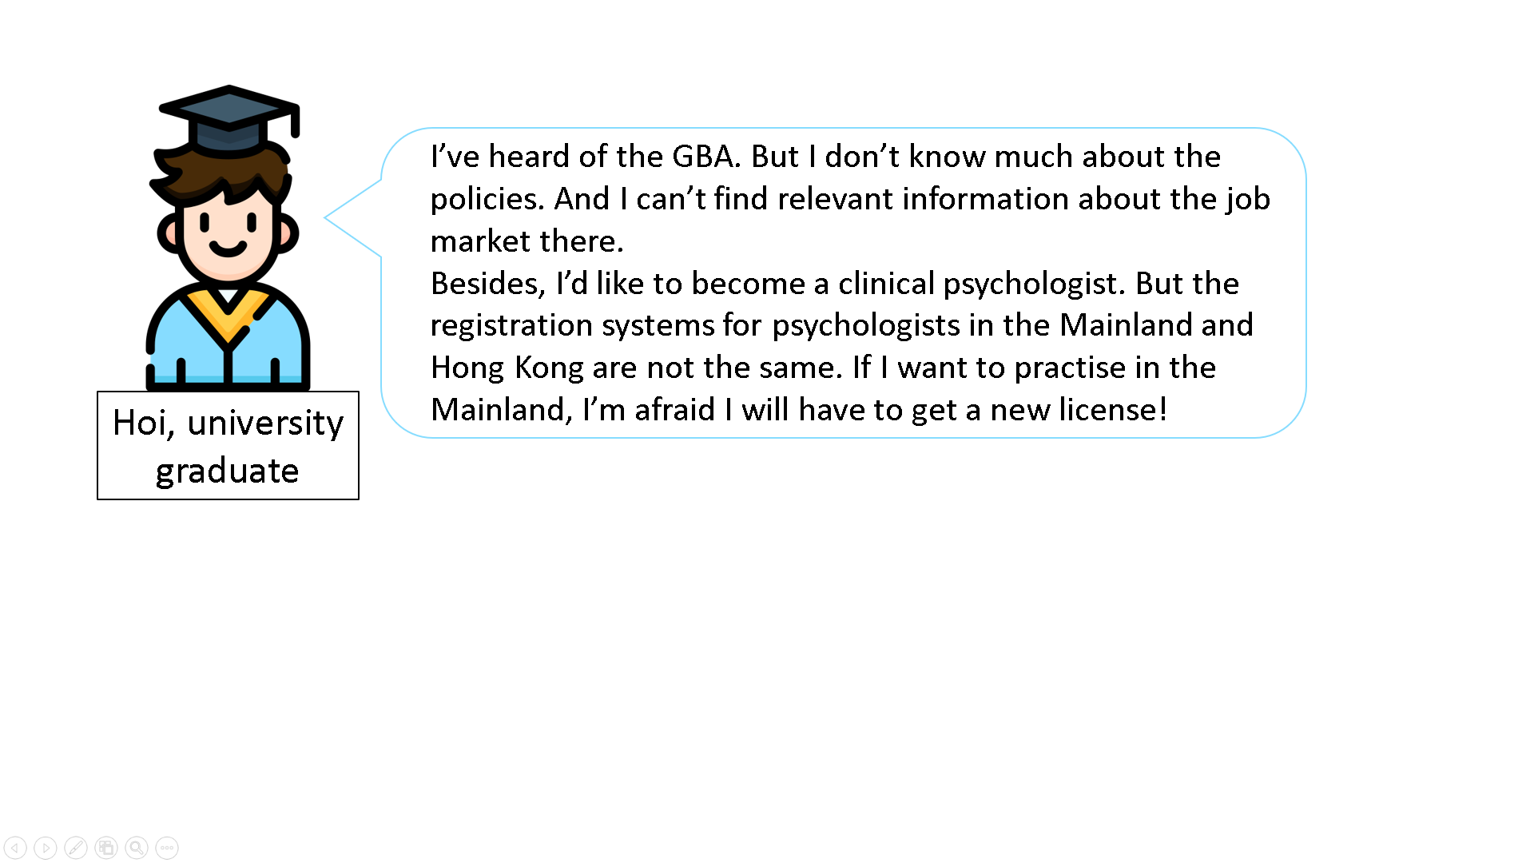

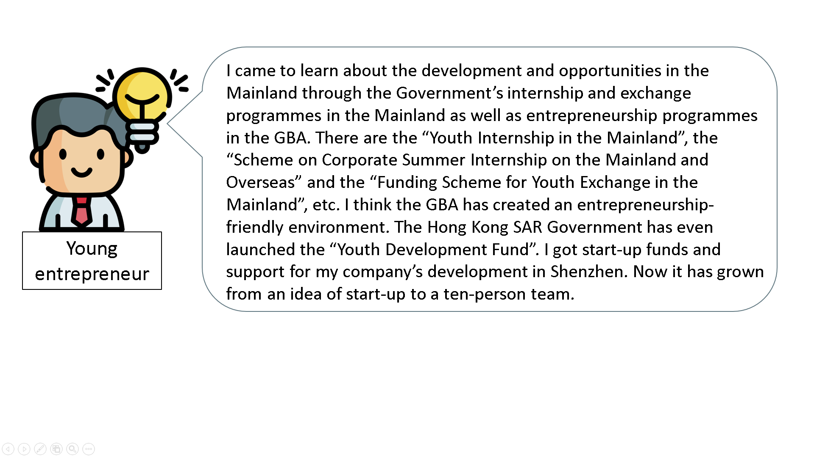

References:

Constitutional and Mainland Affairs Bureau of HKSAR Government (2018). *Youth Innovation and Entrepreneurship*. Greater Bay Area.

Constitutional and Mainland Affairs Bureau of HKSAR Government (2018). *Policy Areas*. Greater Bay Area.

National People’s Congress (11 August 2020). *Decision of the Standing Committee of the National People’s Congress on Authorising the State Council to Implement the Pilot Programme for Hong Kong and Macao Legal Practitioners to Obtain Mainland Practice Qualifications and Practice Law in the Nine Pearl River Delta Municipalities in the Guangdong-Hong Kong-Macao Greater Bay Area.*

MWYO (2020)《香港青年在大灣區就業的可能性及政策建議》

1. Based on the above Sources and your own knowledge, which factors may be currently attractive to young people for considering to work in GBA cities? Name one of the factors and explain.

|  |
| --- |
| *A large number of job opportunities: There are a lot of job opportunities in the* |
| *GBA. Young people of Hong Kong can bring their international vision and* |
| *professional skills into play. The GBA also enjoys policy support from the* |
| *country to facilitate its development. So it is attractive to young people.* |
|  |
| *Internship and exchange activities as well as GBA start-up programmes: The* |
| *Government is committed to promoting internship and exchange activities in the* |
| *Mainland as well as entrepreneurship programmes in the GBA. Such initiatives* |
| *help Hong Kong young people understand the development and opportunities in* |
| *the Mainland and foster their sense of national identity. For example, the “Youth* |
| *Internship in the Mainland”, the “Scheme on Corporate Summer Internship on* |
| *the Mainland and Overseas” and the “Funding Scheme for Youth Exchange in* |
| *the Mainland” help attract young students or fresh graduates to work in the* |
| *GBA.* |
|  |
| *Active measures on cultural development: The Hong Kong SAR Government supports* |
| *cultural projects in the GBA through policies and resources. It helps attract* |
| *young people who are interested in art to pursue their careers in the GBA. For* |
| *example, from 2018-19 onwards, the Hong Kong SAR Government has set aside additional* |
| *resources to support performances or other suitable cultural exchange activities* |
| *by artists and arts groups from Hong Kong with a view to showcasing Hong* |
| *Kong’s arts and culture, while providing new opportunities to Hong Kong* |
| *artists and arts groups, as well as nurturing future administrative staff and* |
| *organisers.* |
|  |
| *Entrepreneurship-friendly environment: The Shenzhen Government encourages* |
| *technology and innovation projects in Shenzhen, Hong Kong and Macao. The* |
| *Hong Kong SAR Government has launched the “Youth Development Fund”* |
| *to provide funds to support entrepreneurship and incubate entrepreneurial* |
| *ideas. Those measures help attract aspiring young entrepreneurs to start* |
| *business in the GBA* |
|  |
| *(Other reasonable answers)* |
|  |
|  |

1. Based on the above Sources, what opportunities do you think the GBA can bring to young people? Please give two examples.

|  |
| --- |
| *The GBA offers many opportunities to aspiring young entrepreneurs, because* |
| *there are a lot of support measures in different cities.* |
| *It also broadens the horizon of young people working in the cultural and arts* |
| *industry, because they can get more performance opportunities.* |
| *Young people with professional skills can benefit from relevant policies. For* |
| *example, lawyers from Hong Kong and Macao can practice in the GBA. They* |
| *have greater flexibility in choosing to work in the GBA.* |
|  |
|  |
|  |

1. Try to cite a challenge that young people from Hong Kong may face when they work in the GBA.

|  |
| --- |
| *Institutional differences: Professionals who work in the GBA may have to adjust* |
| *to a new professional regime and may even need to get a new licence.* |
|  |
| *Habits: There are certain differences in language and habits between Hong* |
| *Kong and the GBA. It may take some time for the youth of Hong Kong to adapt* |
| *when they work in the GBA.* |
|  |
| *(Other reasonable answers)* |

**Reference**

Census and Statistics Department

<https://www.censtatd.gov.hk/en/>

Labour Department – Higher Education Employment

<https://www2.jobs.gov.hk/0/en/jobseeker/hee/>

Human Resources Planning Commission – Talent.gov.hk

<https://www.talent.gov.hk/home?lang=en_US>

Life Planning Information, The Education Bureau

<https://lifeplanning.edb.gov.hk/en/professional-development-for-teachers/teaching-materials-of-different-elements/index.html>

Academy of Chinese Studies

<https://chiculture.org.hk/en/18>

Innovation and Technology Commission, The Government of Hong Kong Special Administrative Region

https://www.itf.gov.hk/en/funding-programmes/nurturing-talent/stem-internship-scheme/

Freepik

https://www.freepik.com/vectors/business'>Business vector created by gstudioimagen - www.freepik.com



1. “Entrepreneurial spirit” includes the qualities of possessing creativity and innovativeness, taking initiatives and responsibilities, taking calculated risks, upholding perseverance in times of uncertainty and seizing the best of the opportunities ahead.